Advanced Malware Evasion Techniques: A Review of Emerging Host-Based Threats and Defenses

Bhuwan Pandey
Department of Computer Science and Engineering, Wright State University
CEG 6420 01, Host Computer Security
Prof. Darron Johnson
November 23, 2025

Abstract
Modern malware has evolved beyond simple exploitation tactics and now incorporates advanced evasion techniques designed to bypass host-based security mechanisms. i.e. including environmental awareness, process injection, fileless execution, polymorphism, and encrypted communication significantly challenge traditional defenses. This paper reviews the landscape of advanced malware evasion strategies, evaluates their associated threats, and examines current host-based countermeasures such as behavioral detection, memory forensics, AI driven analysis, and hardware-assisted security as well. A real world case study of the Emotet and TrickBot malware families highlights the operational use of these techniques. The paper concludes with an outlook on future defensive trends, including zero trust endpoint architectures and deeper hardware level protections.

Introduction
Host based security remains one of the most critical components in defending modern computing environments. As organizations continue to enhance endpoint security through antivirus tools, EDR solutions, and host intrusion prevention systems, adversaries have escalated their methods as well in response. Modern malware increasingly incorporates advanced evasion techniques such as deliberate, sophisticated strategies that help malicious code avoid detection, delay analysis, and persist on a host. These advancements reflect an ongoing escalation between attackers and defenders, where improvements in defensive technology push malware authors to develop stealthier and more adaptive tools. Understanding these evasion methods is essential for developing effective countermeasures and securing host systems against emerging threats.

Defining Advanced Malware Evasion Techniques and Their Relevance
Advanced malware evasion techniques refer to mechanisms specifically designed to circumvent host based security products and automated analysis systems. These techniques are no longer rare. Meaning, they have become standard in malware targeting enterprises, governments, and individual users alike. Their relevance stems from the growing adoption of sophisticated detection technologies. Signature based detection is now insufficient, its prompting malware authors to embed environmental checks, dynamic code modification, and stealth execution pathways.
These evasion strategies matter because they directly undermine security assumptions. A host system may appear clean while actively running malicious code hidden inside legitimate processes or residing only in memory. As endpoints remain a primary vector for breaches such as ransomware attacks, credential theft, and lateral movement, understanding evasion techniques is vital for strengthening defenses.

Associated Threats and Vulnerabilities
Malware evasion techniques introduce a range of threats that exploit weaknesses in host environments.
Process Injection
Malware often hides by injecting code into legitimate, trusted processes such as svchost.exe or explorer.exe. This allows malicious actions to blend with normal system behavior. Security tools that focus on process identification rather than memory behavior are especially vulnerable to this technique.
Fileless Execution
Fileless malware leverages built-in system tools such as PowerShell, WMI (Windows Management Instrumentation), or registry stored scripts, to run entirely in memory without dropping traditional executable files. This eliminates many forensic artifacts and evades traditional antivirus engines focused on file scanning.
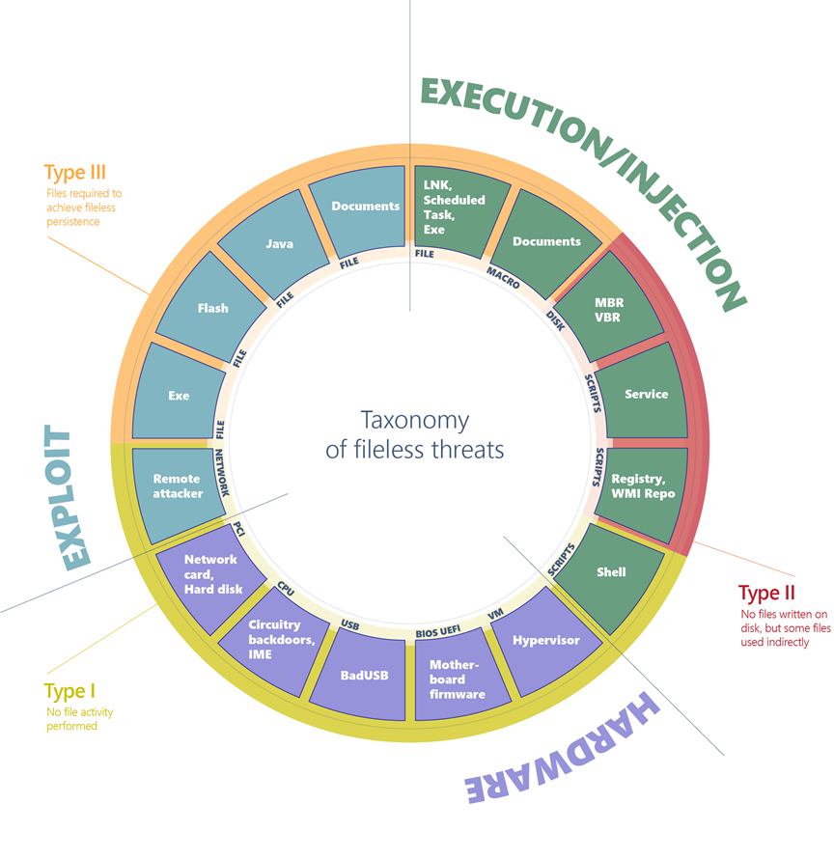
Figure 1. Comprehensive diagram of fileless malware (Microsoft)
Living Off the Land (LOTL) Techniques
Malware frequently abuses legitimate system binaries such as cmd.exe, mshta.exe, or PowerShell to perform malicious tasks. This reduces the need for custom binaries and makes detection significantly more complex.

Current Security Mechanisms and Countermeasures
Defending against modern evasion techniques requires a multilayered host security approach.
Behavioral and Heuristic Detection
Modern EDR platforms monitor process lineage, API calls, script behavior, memory allocation patterns, and anomalous system activity. This allows detection even when malware alters its code structure or hides within legitimate processes.
Anti Fileless Protections
Scripting protections such as PowerShell Constrained Language Mode, AMSI (Antimalware Scan Interface), and WMI logging help expose malicious script execution. Application control mechanisms can restrict the execution of system binaries often abused by fileless malware.
Machine Learning Based Detection
Machine learning models trained on host telemetry can detect malicious behavior patterns that rule based systems might overlook. While not perfect, ML has become a cornerstone of advanced endpoint protection platforms.
Firmware and Kernel Protections
Secure Boot, driver signing enforcement, and kernel isolation reduce opportunities for low level malware to hide on a host. These mechanisms restrict unauthorized modification of system boot processes and kernel memory.

Case Study: Emotet and TrickBot Evasion Capabilities
The Emotet and TrickBot malware families offer clear evidence of the evolution and sophistication of modern evasion. Emotet originally being a banking Trojan, transformed into a modular platform capable of delivering payloads, stealing credentials, and enabling ransomware operations. Its use of polymorphic packers, encrypted payloads, and frequent code updates enabled it to evade traditional antivirus systems. Emotet also leveraged process injection and LOTL techniques to mask its behavior.
TrickBot operated as a secondary stage malware in many Emotet infections. It employed environment detection to avoid sandbox analysis, hid configuration data within obscure registry paths, and frequently updated its modules in response to published security research. TrickBot also utilized kernel level techniques to establish persistence and evade detection.
Together, these malware families demonstrate a highly adaptive approach to evasion, enabling long-term stealth and facilitating devastating follow-on attacks such as Ryuk ransomware deployments.

Future Trends and Potential Improvements
As evasion techniques continue to advance, host-based defenses must evolve accordingly.
Hardware Assisted Detection
Future security platforms will increasingly rely on virtualization and hardware based monitoring. These technologies allow security tools to observe memory and execution flow from outside the guest OS, significantly reducing evasion opportunities.
AI-Driven Endpoint Intelligence
Machine learning models will expand toward cross-endpoint correlation, identifying long running malicious behaviors that appear harmless/gentle in isolation. This will strengthen early detection of stealthy threats that operate in the background.

Zero-Trust Endpoint Security
Zero-trust principles applied to endpoints will minimize assumptions about process trustworthiness. Even system binaries will be continuously verified, limiting the effectiveness of process injection and LOTL (Living Off the Land) attacks.

Conclusion
Advanced malware evasion techniques have become a central challenge in host computer security. As attackers develop new strategies ranging from fileless execution to process injection and polymorphism, defenders must continually strengthen detection capabilities. Modern host security increasingly depends on behavioral analysis, memory forensics, machine learning, and hardware backed defenses. Real world malware families such as Emotet and TrickBot illustrate how effective these evasion strategies can be in practice. Looking forward, advances in virtualization, AI-driven analytics, and zero-trust endpoint frameworks will play essential roles in protecting host systems against evolving malware threats.

References
U. Bayer , P. Milani Comparetti, C. Hlauschek, Christopher Kruegel, Engin Kirda (2009). Scalable, Behavior-Based Malware Clustering. NDSS Symposium.
Chen X., Andersen J., Mao Z., M. Bailey & Nazario J. (2008). Towards an Understanding of Anti-virtualization and Anti-debugging Behavior in Modern Malware. IEEE International Conference on Dependable Systems & Networks.
Kirat D., Vigna G. & Kruegel C. (2014). BareCloud: Bare-metal Analysis-based Evasive Malware Detection. USENIX Security Symposium.
Microsoft. (2024). Fileless Threats. Microsoft Security Blog. Jonathan A. P., M. Sain, Hoon-Jae Lee (2012). Survey on malware evasion techniques: State of the art and challenges. International Conference on Advanced Communication Technology.

